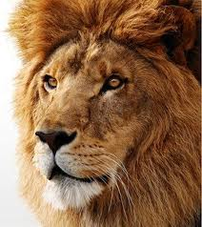

Democratic Candidate

Democratic Candidate

Vote for Ryan the Lion

Vote for Ryan the Lion