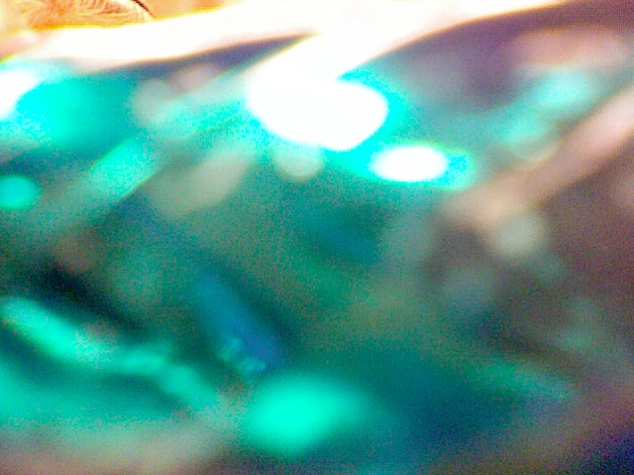

Trust rowan for your new president

Vote For Rowan

Live Life Breathe Air I’ll Get You There