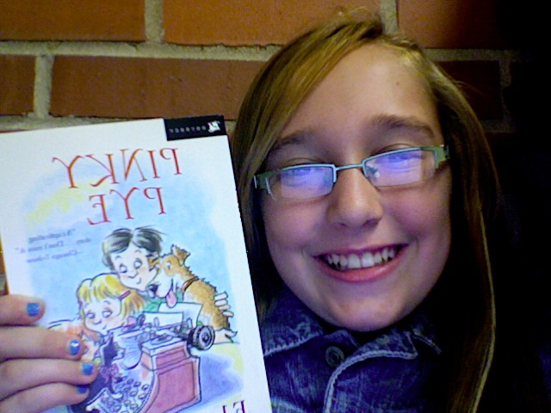

Kelly is fair, it’s just like taking a breath of fresh air!

Kelly is fair, it’s just like taking a breath of fresh air!

* Vote Kelly

# X of X

DVD #

[Insert Date]

[Insert Date]

* Vote Kelly

DVD #

# X of X