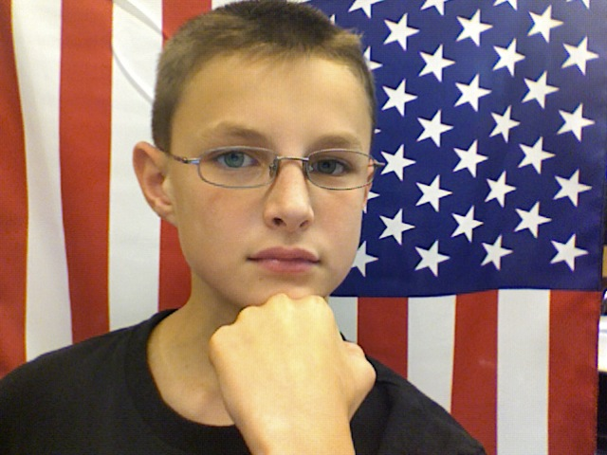



#### Ryan M. for President

Vote for Ryan M.

Ryan the Lion

* Our country will be renewed!
* The less fortunate - more fortunate

## This country does not deserve to be in this shape. Help us make it better.

### Lion King

# Ryan is the best candidate

#### Lorem Ipsum, Eram.

[Phone]

Ryan the Lion

#### Lorem Ipsum, Eram.

[Phone]

#### Lorem Ipsum, Eram.

[Phone]

#### Lorem Ipsum, Eram.

[Phone]

#### Lorem Ipsum, Eram.

[Phone]

#### Lorem Ipsum, Eram.

#### Lorem Ipsum, Eram.

[Phone]

#### Lorem Ipsum, Eram.

[Phone]

#### Lorem Ipsum, Eram.

[Phone]