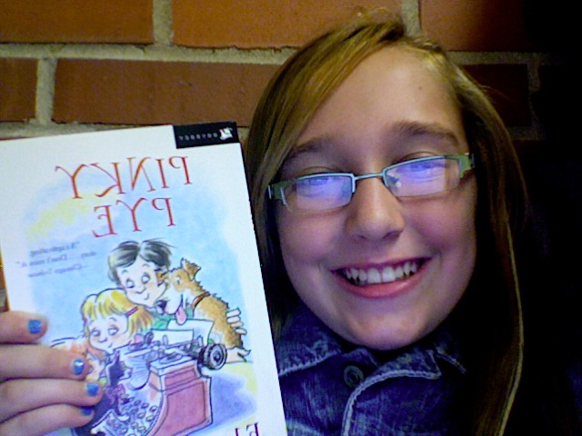

Kelly For

President

Vote now! ☺

Democrat Party

Kelly for President

Vote now! ☺

Vote now! ☺

Vote now ! ☺

Kelly for President

Kelly for President

Quisque nec mi. Integer dapibus magna eget urna.

President

President

President

Kelly For

Kelly For

Kelly For

219 N. Madison, Arizona

219 N. Madison, Arizona

219 N. Madison, Arizona

219 N. Madison, Arizona

Sep. 29th 2012

Sep. 29th 2012

Kelly has a mom named Jennifer, a dad named Rick, older brother named Holden, a younger sister named Jody, and a pet frog named Perry.

## Democratic Party Convention

## Democratic Party Convention

## Democratic Party Convention

# vote kelly! ☺

# vote kelly! ☺

Blaze Anderson

Kelly for President

1105 W. Brooklyn Hollywood CA.

1105 W. Brooklyn Hollywood CA.

Kelly

1105 W. Brooklyn Hollywood CA.

Student Account

Kelly for President

Address]

1105 W. Brooklyn Hollywood CA.

1105 W. Brooklyn Hollywood CA.

1105 W. Brooklyn Hollywood CA.

Student Account

## Democratic Party Convention

Kelly for President

Kelly has a mom named Jennifer, a dad named Rick, older brother named Holden, a younger sister named Jody, and a pet frog named Perry.

# vote kelly! ☺

Sep. 29th 2012

Student Account

Kelly has a mom named Jennifer, a dad named Rick, older brother named Holden, a younger sister named Jody, and a pet frog named Perry.

Sep. 29th 2012

Sep. 29th 2012

Kelly has a mom named Jennifer, a dad named Rick, older brother named Holden, a younger sister named Jody, and a pet frog named Perry.

# vote kelly! ☺

Blaze Anderson

219 N. Madison, Arizona

Blaze Anderson

Blaze Anderson