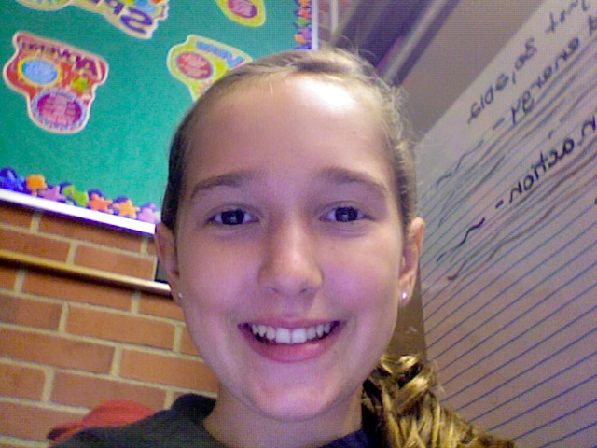

Vote for Kelly because she is loyal ,intelligent and will try her best to be the best president you ever had. Kelly is ten years old has a mom a dad a little sister a older brother and a pet frog. Kelly enjoys playing sports like basketball and tennis .Her favorite color is orange. Her favorite movies are the whole Harry Potter seies

Choose Kelly for the Democratic party

President

Lorem ipsum dolor sit amet, consectetuer adipiscing elit.

Lorem ipsum dolor sit amet, consectetuer adipiscing elit.

Etiam porta consectetuer dui.

Etiam porta consectetuer dui.

Quisque nec mi. Integer dapibus magna eget urna.

Quisque nec mi. Integer dapibus magna eget urna.

Quisque nec mi. Integer dapibus magna eget urna.

Pellentesque

Pellentesque

Pellentesque

Kelly for

Aliquam fermentum

Aliquam fermentum

Aliquam fermentum

## In pede felis, semper vel, cursus vitae, ullamcorper quis, nibh.

# Pellentesque

[Insert Date]

Student Account

[Street Address]  
[City], [State][Postal Code]

Nulla vel dolor non diam hendrerit eleifend. Nunc viverra. Vestibulum blandit lectus nec velit. Suspendisse ut mauris. Suspendisse ut mi. bibendum elit massa sit amet urna.

## In pede felis, semper vel, cursus vitae, ullamcorper quis, nibh.

# Pellentesque

[Insert Date]

Student Account

[Street Address]  
[City], [State][Postal Code]

Nulla vel dolor non diam hendrerit eleifend. Nunc viverra. Vestibulum blandit lectus nec velit. Suspendisse ut mauris. Suspendisse ut mi. bibendum elit massa sit amet urna.

[Insert Date]

Student Account

[Street Address]  
[City], [State][Postal Code]

Nulla vel dolor non diam hendrerit eleifend. Nunc viverra. Vestibulum blandit lectus nec velit. Suspendisse ut mauris. Suspendisse ut mi. bibendum elit massa sit amet urna.

## In pede felis, semper vel, cursus vitae, ullamcorper quis, nibh.

# Pellentesque

[Street Address]  
[City], [State][Postal Code]

[Insert Date]

Nulla vel dolor non diam hendrerit eleifend. Nunc viverra. Vestibulum blandit lectus nec velit. Suspendisse ut mauris. Suspendisse ut mi. bibendum elit massa sit amet urna.

## In pede felis, semper vel, cursus vitae, ullamcorper quis, nibh.

# Pellentesque

Address Line 1  
Address Line 2  
Address Line 3  
Address Line 4

Recipient

Address Line 1  
Address Line 2  
Address Line 3  
Address Line 4

Recipient

Address Line 1  
Address Line 2  
Address Line 3  
Address Line 4

Recipient

Student Account

Recipient

Address Line 1  
Address Line 2  
Address Line 3  
Address Line 4