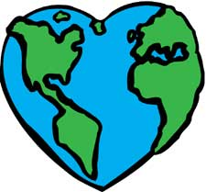

I will try and try to make are Earth cleaner. We should create groups that clean up are beaches. We cold run our trains on electricity. I will do anything to help.