[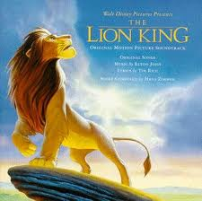](http://www.google.com/imgres?q=lion+king&hl=en&client=firefox-a&rls=org.mozilla:en-US:official&biw=650&bih=496&tbm=isch&tbnid=OMRrHa0s5gkZ_M:&imgrefurl=http://radio.lionking.org/&docid=MQODMRTYRa_iRM&imgurl=http://radio.lionking.org/original.jpg&w=301&h=300&ei=_nZbUNLSAom69gSGg4DQCw&zoom=1&iact=hc&vpx=294&vpy=4&dur=55728&hovh=224&hovw=225&tx=103&ty=125&sig=111140349332610627566&page=2&tbnh=152&tbnw=142&start=9&ndsp=10&ved=1t:429,r:1,s:9,i:172)

Vote for Ryan the Lion for President. Democratic candidate. He is the lion king.